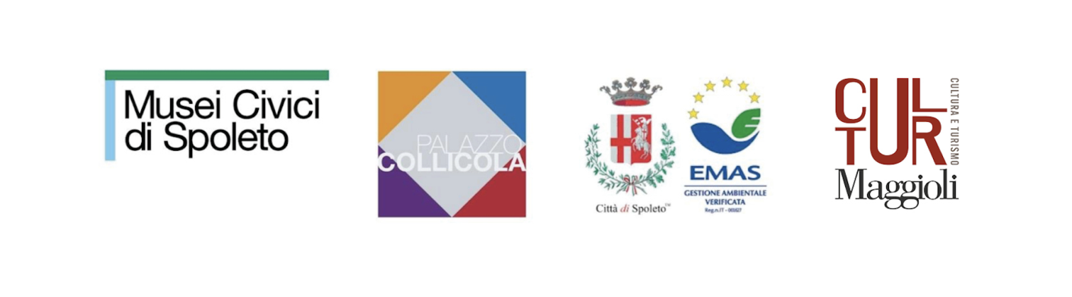
PALAZZO COLLICOLA
OPENING OF THE SUMMER EXHIBITIONS
Inauguration: Saturday, June 28, 2025, at 11:00 am
Palazzo Collicola, piazza Collicola 1, Spoleto

Pensieri fuggitivi, a solo exhibition by William Kentridge, curated by Saverio Verini

Listen to your eyes. Opere e letterature artistiche da una collezione privata, featuring a selection of works from the De Donno Collection, curated by Primo De Donno, Saverio Verini, and ViaIndustriae

Festival dei Due Mondi: Posters 1958–2025

Corpi d’aria, solo show by Stefano Cerio, curated by Stefano Chiodi

Mahler & LeWitt Studios: 10 years of activity, curated byGuy Robertson

Press release

On Saturday, June 28, 2025, starting at 11:00 am, Palazzo Collicola in Spoleto will inaugurate its new exhibition program. This cycle of exhibitions, running throughout the summer until early November 2025, features five new projects: a solo show by internationally renowned artist William Kentridge titled Pensieri fuggitivi (Fugitive Thoughts), curated by Saverio Verini; an exhibition presenting a selection of works from the collection of Primo De Donno; a retrospective of posters from the Festival dei Due Mondi; a solo show by Stefano Cerio titled Corpi d’aria (Bodies of Air); and an exhibition celebrating ten years of activity of the Mahler & LeWitt Studios association, active in Spoleto since 2015.
With this series of events, Palazzo Collicola continues the celebration of its 25th anniversary, a milestone marked throughout 2025 with a rich program of exhibitions and initiatives. Also participating in the summer openings is the Church of Saints John and Paul, one of the venues of the Spoleto Civic Museums, which will host a solo exhibition by Gianni Politi titled Le cose non saranno mai più come prima (del potere anarchico dell'amore) [Things Will Never Be the Same (On the Anarchic Power of Love)], curated by Saverio Verini.
The exhibition program is made possible by the Municipality of Spoleto, in collaboration with the Festival dei Due Mondi, Lia Rumma Gallery, William Kentridge Studio, Fondazione CaRiSpo, Amici di Palazzo Collicola Association, Viaindustriae, Mahler & LeWitt Studios, University of West Georgia, and with the support of Maggioli Cultura e Turismo.

Pensieri fuggitivi (Fugitive Thoughts) is the title of the exhibition by William Kentridge that takes over the Piano Nobile of Palazzo Collicola. Curated by Saverio Verini, Director of the Civic Museums of Spoleto, in collaboration with the William Kentridge Studio and Lia Rumma Gallery, the exhibition features a wide selection of works created by the South African artist—one of the most influential figures in the international contemporary art scene—over the past twenty-five years. This extended time frame allows visitors to grasp the depth, consistency, and evolution of Kentridge’s artistic sensibility, offering a broad and multifaceted view of his oeuvre. The exhibition includes drawings, sculptures, videos, prints, and notebooks, composing a rich and nuanced repertoire of over fifty works. The title Pensieri fuggitivi not only references a video work featured in the show (Fugitive Words), but also reflects the conceptual foundation of Kentridge’s practice—constantly in motion, where nothing is final and everything holds the potential to spark unexpected connections. The exhibition is the result of a collaboration between Palazzo Collicola and the Festival dei Due Mondi. In addition to participating in the Festival's program with his performance The Great Yes, the Great No, William Kentridge also designed the official poster for Spoleto68, adding his name to the long list of internationally renowned artists associated with the event.
The ground floor will host Listen to Your Eyes. Artistic Works and Literatures from a Private Collection, an exhibition showcasing a selection of works from the collection of Primo De Donno—one of the most sophisticated private collections in Italy, housed in Foligno, just a few kilometers from Spoleto. The collection includes works by major figures such as Giorgio de Chirico, Lucio Fontana, Alberto Burri, Piero Manzoni, Mario Schifano, Alighiero Boetti, Gino De Dominicis, Enzo Cucchi, and extends to artists who emerged in the 1990s such as Vanessa Beecroft and Stefano Arienti. What sets the collection apart is its exceptional assemblage of books, documents, and ephemera accompanying the artworks, which help reconstruct the cultural context in which the works were created and their critical reception over time. Curated by Primo De Donno, Saverio Verini, and Viaindustriae, the exhibition centers on the dual relationship between artworks and the “literature” surrounding them: a journey through key figures and poetics, movements and currents of the 20th century to the present, embracing a century of art history.
Also on the ground floor, Festival dei Due Mondi: Posters 1958–2025 will be on display—a special exhibition section dedicated to the festival’s posters created from 1958 to the present day. This exhibition offers a journey through the history of art and the Festival itself, while also serving as a tribute to the city of Spoleto. Balthus, Daniel Buren, Alberto Burri, Enzo Cucchi, Willem De Kooning, Niki de Saint Phalle, Helen Frankenthaler, David Hockney, Jasper Johns, Anish Kapoor, Joan Miró, Luigi Ontani, Cy Twombly, and Emilio Vedova are just some of the major artists who have contributed poster designs over the course of the Festival’s 68 editions. The exhibition is made possible thanks to a new collaboration between the Civic Museums of Spoleto, the Festival dei Due Mondi, and the University of West Georgia—an institution that has long maintained a relationship with the city of Spoleto.
On the second floor of Palazzo Collicola, Corpi d’aria (Bodies of Air) will be presented—an exhibition curated by Stefano Chiodi featuring a selection of photographs by Stefano Cerio. The project is part of the public initiative “Strategia Fotografia”, promoted by the Directorate-General for Contemporary Creativity of the Italian Ministry of Culture, with Palazzo Collicola among the selected institutions. Thanks to this initiative, the museum acquired two photographic series by Cerio: Aquila and Brenva. In Aquila (2019–2021), the artist installed inflatable churches, castles, and slides in the landscapes surrounding the city of L’Aquila—devastated by the 2009 earthquake—capturing these surreal interventions in moments of stillness and silence, as if awakening these deserted places through carnival-like structures. In Brenva (2023), named after the famous glacier at the foot of Mont Blanc, now rapidly retreating due to climate change, Cerio constructed an inflatable wall placed where the glacier’s edge once stood. This ephemeral structure visualizes the space lost in recent years and symbolically represents the limits of our vision and our inability to foresee the future.
Both projects carry a strong conceptual foundation and lie at the intersection of photography, contemporary art, and environmental art. They bring different artistic languages into dialogue to document the profound transformations of our time.
On the first floor, in the room adjacent to the Carandente Library, Mahler & LeWitt Studios: 10 Years of Activity will be on display—an archival exhibition celebrating the tenth anniversary of the association, curated by Guy Robertson. Active since 2015 in the former studios of Anna Mahler and Sol LeWitt, as well as at the Torre Bonomo, the Mahler & LeWitt Studios have played a vital role in Spoleto’s cultural landscape. Over the past decade, the Studios have supported the city’s creative life through artist residencies, special projects, and educational programs for schools—all of which will be revisited and documented in the exhibition.
In addition to Palazzo Collicola, the Church of Saints John and Paul—one of the venues of the Spoleto Civic Museums—will host Le cose non saranno mai più come prima (del potere anarchico dell'amore) [Things Will Never Be the Same (On the Anarchic Power of Love)] a contemporary art intervention by Gianni Politi (Rome, 1986), curated by Saverio Verini. Within the former church, Politi will present a series of paintings and two sculptures, engaging in a dialogue with the site’s historical function and its layered frescoes. The project creates a dynamic exchange between contemporary artistic language and the sacred, stratified architecture of the space.
Other locations around the city will also come alive with contemporary art and cultural initiatives, thanks to the efforts of prominent local foundations and associations, including the Fondazione Carla Fendi and Mahler & LeWitt Studios. In collaboration with Spoleto68 / Festival dei Due Mondi, they will host The Centre for the Less Good Idea, presenting both an exhibition and a residency program. The exhibition, titled Unhappen Unhappen Unhappen – Pepper's Ghost Dioramas, will feature the premiere of four animated dioramas created using the Pepper’s Ghost technique by Anathi Conjwa, William Kentridge, Micca Manganye, and Sabine Theunissen. Pepper’s Ghost is a theatrical illusion technique dating back to the Victorian era, and has become one of the signature tools used by the Centre. Founded in Johannesburg, South Africa, by William Kentridge and Bronwyn Lace, The Centre for the Less Good Idea fosters collaborative and interdisciplinary projects, with a special focus on supporting young artists from across the African continent. The Centre’s unique philosophy encourages artists to pursue the so-called “less good idea”—those ideas that initially seem marginal, accidental, or born from creative blocks, but ultimately open up unexpected and generative possibilities. The Centre will share its philosophy and methods through a series of workshops and public events, including a hands-on introduction to the Pepper’s Ghost technique, a live composition workshop using silent film archives, and in-depth conversations with the participating artists.

Artists’ Biography
William Kentridge was born in Johannesburg, South Africa, in 1955. He is internationally recognized for his drawings, films, theatrical and operatic productions. His method combines drawing, writing, cinema, performance, music, theater, and collaborative practices to create artworks rooted in politics, science, literature, and history, while maintaining space for contradiction and uncertainty.Since 1990, Kentridge’s works have been exhibited worldwide in museums and galleries including the Museum of Modern Art in New York, the Albertina Museum in Vienna, the Louvre Museum in Paris, the Whitechapel Gallery in London, the Louisiana Museum in Copenhagen, the Reina Sofía Museum in Madrid, the Kunstmuseum Basel, Zeitz MOCAA and the Norval Foundation in Cape Town, and the Royal Academy of Arts in London. He has participated multiple times in Documenta Kassel (2012, 2002, 1997) and the Venice Biennale (2015, 2013, 2005, 1999, and 1993). His opera productions include Mozart’s The Magic Flute, Shostakovich’s The Nose, and Alban Berg’s operas Lulu and Wozzeck, performed at renowned opera houses such as the Metropolitan Opera in New York, La Scala in Milan, English National Opera in London, Opéra de Lyon, Opera Amsterdam, Sydney Opera House, and the Salzburg Festival. Kentridge’s theatrical productions, performed worldwide, include Refuse the Hour, Winterreise, Paper Music, The Head & the Load, Ursonate, Sibyl, The Great Yes, the Great No, and, in collaboration with Handspring Puppet Company, Ubu & the Truth Commission, Faustus in Africa!, The Return of Ulysses, and Woyzeck on the Highveld. In 2016, Kentridge founded the Centre for the Less Good Idea in Johannesburg, a space dedicated to reactive thinking and creation through experimental, collaborative, and interdisciplinary artistic practices. The centre hosts ongoing workshops, public performances, and mentoring activities.Kentridge has received honorary doctorates from numerous universities, including Yale, the University of London, and Columbia University. In 2010, he was awarded the Kyoto Prize. In 2012, he was named Commandeur in the French Ordre des Arts et des Lettres and delivered the Charles Eliot Norton Lectures at Harvard University. In 2015, he was made an Honorary Academician of the Royal Academy of Arts in London. In 2017, he received the Princesa de Asturias Award for the Arts, and in 2018, the Antonio Feltrinelli International Prize. In 2019, he was awarded the Praemium Imperiale for Painting in Tokyo. In 2021, he became a Foreign Associate Member of the Académie des Beaux-Arts in Paris. In 2022, he received the Order of the Star of Italy, and in 2023, the Olivier Award for Excellence in Opera for Sibyl in London. Kentridge’s works are held in the collections of numerous museums, including the Art Gallery of Western Australia (Perth); Art Institute of Chicago; Carnegie Museum of Art (New York); San Diego Museum of Art; Fondation Cartier (Paris); Zeitz MOCAA (Cape Town); Norval Foundation (Cape Town); LACMA (Los Angeles); Haus der Kunst (Munich); Sharjah Art Foundation; Mudam (Luxembourg); Musée d’Art Contemporain de Montréal; MoMA (New York); SF MoMA (San Francisco); Castello di Rivoli (Turin); Moderna Museet (Stockholm); MoCA (Los Angeles); Stedelijk Museum (Amsterdam); National Gallery of Victoria (Melbourne); Johannesburg Art Gallery; MAXXI (Rome); Louisiana Museum (Humlebaek, Denmark); National Gallery of Canada (Ottawa); National Museum of Modern Art (Kyoto); Israel Museum (Jerusalem); Inhotim Museum (Brumadinho, Brazil); Broad Art Foundation (Los Angeles); Centre Pompidou (Paris); Fondation Louis Vuitton (Paris); National Gallery of Australia (Canberra); Tate Modern (London); Sifang Art Museum (Nanjing); Kunsthalle Mannheim; Vehbi Koç Foundation (Istanbul); Luma Foundation (Arles); Museum of Fine Arts (Budapest); Fundació Sorigué (Lleida); Guggenheim Abu Dhabi; Kunsthalle Praha (Prague); Amorepacific Museum of Art (Seoul), as well as many private collections worldwide.
Stefano Cerio lives and works between Rome, where he was born in 1962, and Paris. Since 2001, he has focused on research photography and video. In 2024, he exhibited at the MAXXI Museum as part of an installation project featuring works from the museum’s collection, curated by artist Alex Da Corte. In 2021, Cerio created a work for the new MAXXI museum location in L’Aquila, followed in 2022 by the publication of the book Aquila by Hatje Cantz. In 2019, the Italian Cultural Institute in Paris showcased his Constructions instables series. In 2018, the Museo Pignatelli in Naples dedicated a major retrospective to him, while in 2017 Hatje Cantz published the book Night Games, which led to a solo exhibition at Camera in Turin. His 2015 series Chinese Fun, first exhibited in 2013 at Noire Contemporary Art in Turin, was published as a book by Hatje Cantz and shown at the VOLUME! Foundation in Rome. In 2014, he exhibited Cruise Ship at the Mois de la Photo in Paris. In 2012, he presented the Night Ski series at Studio Trisorio in Naples, and in 2011, WinterAquapark at the Forma Foundation in Milan, accompanied by a publication from Contrasto. That same year, he showed the video Summer Aquapark at MAXXI in Rome. In 2010, Cerio held two exhibitions at the Galerie Italienne in Paris and participated in the group show O’Vero at the Madre Museum in Naples. In 2005, the Città della Scienza in Naples dedicated a solo show to him titled Codice Multiplo.
Gianni Politi (Rome, 1986) studied philosophy at “La Sapienza” University in Rome. Using classical materials from the Italian painting tradition, he has developed a practice based on private processes that take place in the studio, aiming to generate spontaneous images. The studio thus becomes both the subject and object of a varied painting practice that also extends to the use of sculptures, narrating the daily effort involved in painting today. In his attempt to redefine abstract painting in the contemporary context, Politi infuses his work with personal experiences and recurring themes, reflecting on primary subjects such as love, friendship, and sexuality, while constantly seeking to mythologize the materials he uses. The artist has exhibited his work in various national and international institutions, including the Galleria Nazionale d’Arte Moderna in Rome, Nomas Foundation, MAXXI, MACRO, and the Italian Cultural Council in Prague. His work is represented by Galleria Lorcan O’Neill in Rome.
__________________________________________________________________________
OPENING AND HOURS
Location: Palazzo Collicola, Piazza Collicola 1, Spoleto (Pg)
Dates: June 28 – November 2, 2025
Opening hours: Wednesday to Monday, 10:30 AM – 1:00 PM / 2:30 PM – 6:00 PM
Closed on Tuesdays (Last admission 30 minutes before closing)
Tickets:
- Full price: €7.50
- Reduced: €5.00 (ages 18 to 25)
- Free admission: children and youth under 18, students of Fine Arts Academies and art/performance-related disciplines, people with disabilities (benefit extended to one accompanying person), ICOM members, members of the Friends of Palazzo Collicola Association, journalists, and tour guides.
Contacts:
Phone: +39 0743 46434
Email: info@palazzocollicola.it / spoletomusei@gmail.com
Website: www.palazzocollicola.it
___________________________________________________________________________

The exhibition Fugitive Thoughts by William Kentridge is presented in collaboration with the Festival dei Due Mondi and the Lia Rumma Gallery Milan-Naples.
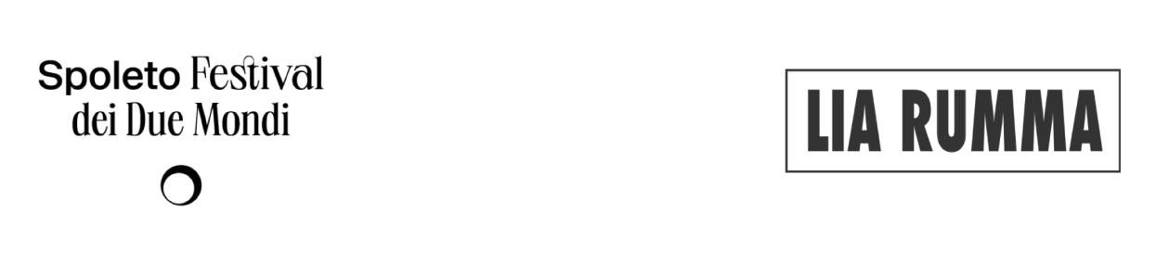___________________________________________________________________________

Corpi d’aria, solo exhibition by artist Stefano Cerio
The project Corpi d’aria by Stefano Cerio is supported by the public call “Strategia Fotografia,” promoted by the Directorate-General for Contemporary Creativity of the Ministry of Culture, which selected Palazzo Collicola among the participating institutions.
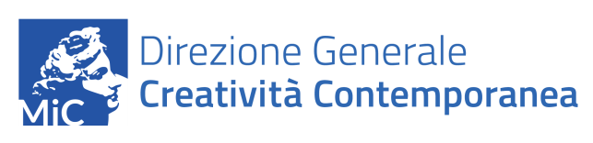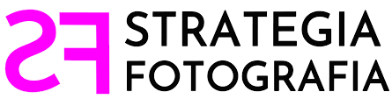

___________________________________________________________________________

The exhibition Festival dei Due Mondi: Posters 1958-2025 is presented in collaboration with the Festival dei Due Mondi and the University of West Georgia.
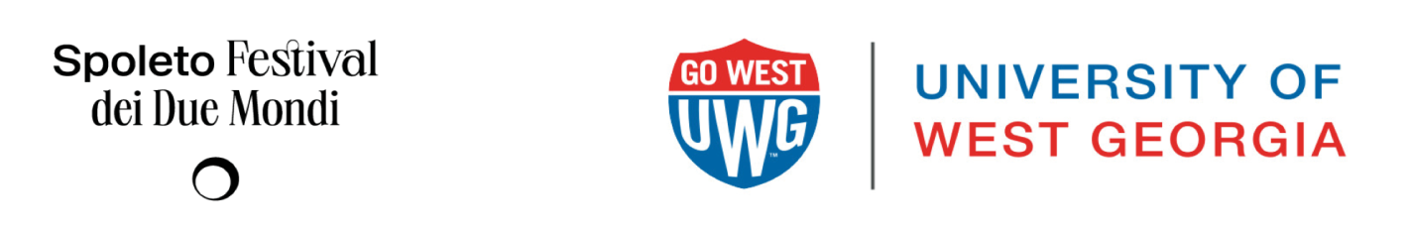
___________________________________________________________________________

The exhibition Listen to your eyes. Artistic Works and Literatures from a Private Collection is realized with the support of the CaRiSpo Foundation, in collaboration with ViaIndustriae Publishing and the Friends of Palazzo Collicola Association.

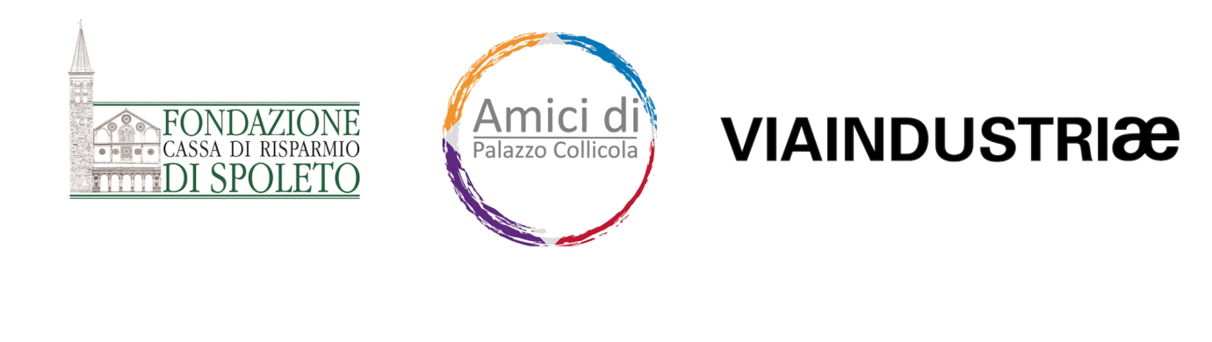
___________________________________________________________________________

The exhibition Unhappen Unhappen Unhappen – Pepper's Ghost Dioramas and its related residency program are presented by the Carla Fendi Foundation and the Mahler & LeWitt Studios Association in collaboration with Spoleto68 Festival dei Due Mondi.




